**Basic instructions for Matrix inversion code**

1. Start Matlab
2. Set the paths in Matlab

In Home/Set Path add software for Dirk with all subfolders.

Other ways to do it: -

addpath(genpath('C:\D\Raman\MI_Mtlb\2016\'))

or add them to the pathdef.m file

1. Open Raman GUI

* In Matlab Command Window type “guide”
* browse to the “your_path/GUI” folder and select Raman_GUI.

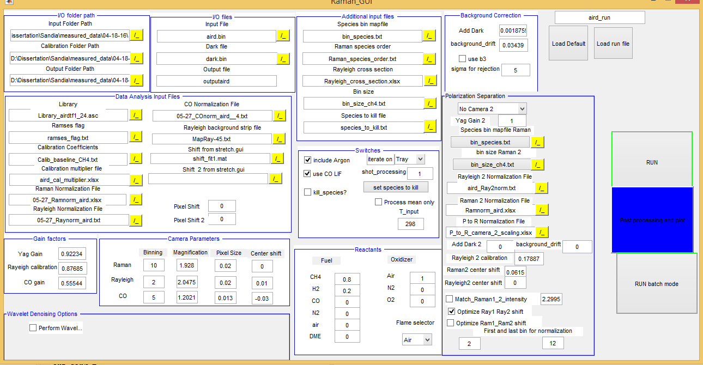

Figure 1 Screenshot of Raman GUI

Comment: Start from data in “data for testing” to familiarize with the code.

Getting the GUI started

* Press the green arrow to start the GUI (or tools/Run if no green arrow is present)
* Press the “load Run file “ button and select the run file “run.txt” in “Software for Dirk/data for testing/Calibration” ( in C:\D\Raman\MI_Mtlb\2013\Examples)

I/O folder path

Change the parameters in I/O folder path section by clicking the ./ yellow button:

* Set “input folder path” to “your_path/data_for_testing”
* Set “Calibration folder path” to “your_path/data_for_testing/Calibration”
* Set “Output folder path” to “your_path/data_for_testing/Output”

I/O files

* Select the input .bin file (for example aird.bin)
* Select the corresponding dark file (for example dark.bin)
* Type the desired output file name (if you don`t like the default one)

Additional input files

This section points to some input files that are required but that you`ll probably never change for a given dataset.

Bin_species.txt contains in the first column the species of interest, the other columns the camera bin (or bins) associated to it. For example CO2 2 3 -1 means that bin 2 and 3 of the camera will be associated to CO2. The -1 is used to assign 3 columns to all species independently of the number of bins actually used.

Raman_species_order indicates the order in which the different species are stored in the matrix. No need to modify it unless you`re adding more species.

Rayleig_cross_section.txt contains the Rayleigh cross section and the molecular weight of all species. It also contains C2 and B3 (terms that appear in the matrix inversion but that do not contribute to the mass or mole fraction) but the values are set to 0.

Bin_size_ch4.txt contains the number of pixel in each bin. It depends on the binning applied on the camera, so it is generally the same for an entire dataset.

Species_to_kill.txt is a text file containing a list of species to suppress during the calculation. It affects the results only if the switch “kill species?” is active.

Background correction

This section includes parameters to improve the background correction.

Background drift is a uniform shift of the background (binned) level.

AddDark is a shift to the dark that is proportional to the energy of the Yag laser (on a single shot-basis) and to the size of the bin.

The 2 parameters are determined from air files. Background drift changes during a day, AddDark is considered a constant throughout the day.

Useb3 is a switch. When selected it forces the mean value (over the total number of shots) of the b3 channel to be 0.

Sigma for rejection is used for a rejection criterion of bad shots based on the background channel and the Yag laser energy. Shots for which the B3 channel or the Yag laser energy differ from their mean by more than number of “sigma_for_rejection” standard deviations they are considered bad shots and removed.

Data analysis input files

Library: select the appropriate library file (see instructions in the Calibration section on how to generate it). Typically choose the library file generated based on an air file close in time to the data you`re analyzing.

Ramses flag: file indicating which species and crosstalk are used from the Ramses library. The first 2 column identify the species-crosstalk term (same order as in the Raman species order file), the last column is set to 1 if the Ramses library is used, to 0 if the old Sandia polynom is used.

Calibration coefficients is the file containing the Raman cross section for all species and crosstalks. It also contains the temperature dependence, but they are not used for species or crosstalk for which the ramses flag is set to 1. This set is typically left unaltered.

Calibration multiplier is an excel file containing for each species and crosstalk a scalar that multiplies the cross section reported in the calibration coefficient. This file is obtained from the calibration routine described later on in this document. Typically you`ll use a few of these files to analyze a data set collected during a day

Raman normalization file is a .xlsx file containing normalization curves for all the Raman species. During the calibration process you`ll generate as many of these curves as air data sets collected. Order is:

|  |  |  |  |  |  |  |  |  |
| --- | --- | --- | --- | --- | --- | --- | --- | --- |
| A | B | C | D | E | F | G | H | I |
| CO2 | O2 | CO | N2 | CH4 | H2O | H2 | C2 | B3 |

Rayleigh normalization file, same as above but for the Rayleigh signal and .txt. file.

CO normalization curve, same as above but for the CO LIF. Typically only one from data taken at the beginning of the day is available.

Rayleigh background strip file indicates which strips are used for further background subtraction in the Rayleigh data processing. Do not change it for Sandia data, but you may need to adapt it to you setup for your data. Has same number of strips as Ray image (perpendicular to beam)

Shift form stretch gui: gives data for widening up the beam generated by stretch_GUI in Calibration step from comparing spectrally resolved N2 and O2 spectra

Pixel shift: add the shift between the experimental spectrum and the spectrum generated by Ramses. You`ll need a full resolution N2 spectrum to determine it. As an alternative you can play around with this parameter to reduce errors in the bowing correction (not recommended, but sometimes necessary)

Switches

Include argon: add argon to the results as a fraction of the N2 content based on standard air composition. Deselect if air is not the only source of N2.

Use CO LIF: if selected the algorithm uses CO LIF measurements to compute mole, mass fractions etc.., otherwise it will use the Raman CO.

Kill species: select to kill some species. A pop up windows appear allowing you to select species to kill. It then writes the species to the species_to_kill.txt file. Performed by multiplying it with a small factor

Iterate on: allow choosing between T Rayleigh, T perfect gas and thermocouple temperature. In the last case it does not iterate, but fix the temperature. (this last option is used during the calibration process for air, or pure gases).

Missing:

Iterate on T_input, Process mean only,

Not there any more? Shotprocessing: set to 1 to analyze every shot, 2 will analyze every 2 shots and so on. Useful to take a quick look at large data sets (I put it there a long time ago, but maybe I never tested it).

Gain factors

Yag gain: determined from the calibration routine to match the perfect gas temperature to thermocouple temperature in air

Rayleigh Calibration: determined from the calibration routine to match the Rayleigh temperature to thermocouple temperature in air

CO gain: determined from the calibration routine to match the CO LIF measurements to the predicted values in a premixed rich flame (ch4-8.bin typically)

Camera parameters

Parameters for the 3 cameras. Modify it if you are processing data not from Sandia. The last column, center shift is used to correct for relative shift of the 2 cameras (in vflame look at Tray/Tpg and the CO and CO-LIF peak locations)

* Bining: refers to binning along probe volume

Reactants

This section is used as in input in calculating the mixture fraction. Select the relative concentration of the species in the oxidizer and fuel streams.

Flame selector: Set to CH4. (it comes from a version of the code before my time, and was used in the plotting routine. I changed many things and it is destined to obsolescence, but there might be few places where I need to remove it)

Update

Press the update button to save the changes

Calibration GUI

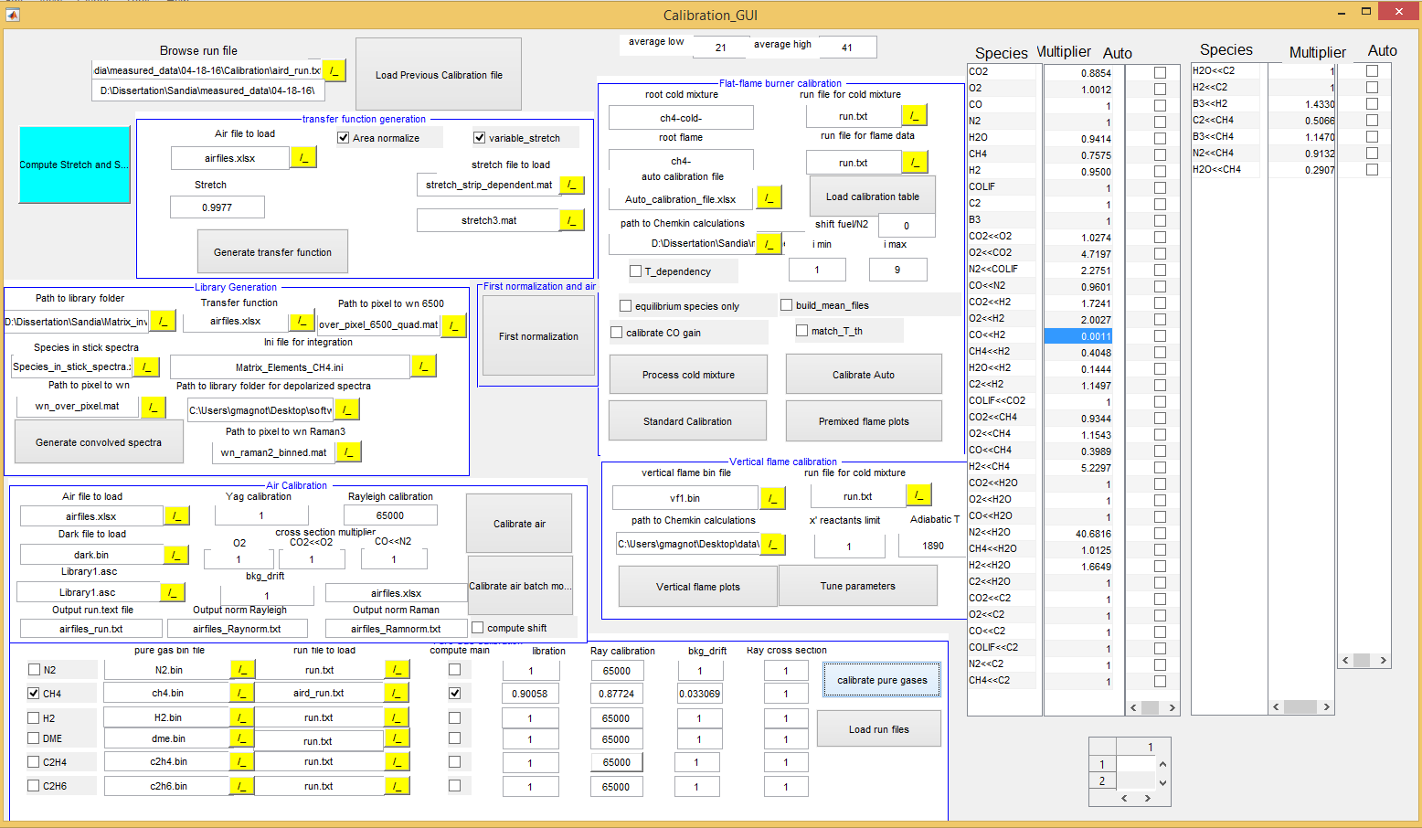

The GUI generates all the files needed in the main MI inversion code.

First load the GUI. As done previously, type “guide” in the Matlab command window, then browse and select “your_path /GUI/Calibration_GUI.fig”. Press the green arrow to start the GUI.

In the previous step you opened the Raman GUI, loaded a run file and changed the I/O path, correct? If not do it now.

With the correct I/O path, load the run.txt file in the calibration folder (“your data path/Calibration”). First select the appropriate run file by pressing the yellow “./” symbol and then press “Load run file”. It will fill the 2 large arrays on the right side with the content of the calibration multiplier file indicated in the run file. Important!!! To change the input for this subroutine you need to reload the file to have an effect.

Library generation

The Library_spectra/stick_spectra folder contains stick spectra generated from Ramses for all the species of interest. I no longer use the convolution included in Ramses. There are a couple of reasons for that: 1) the Ramses stick spectrum does not depend on the specific of the set-up, so it can be generated only once.

Transfer function generation

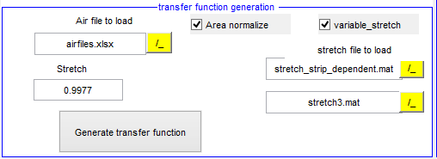

This section generates the transfer function out of the airfiles

* Path to library folder: …/subroutines/Library_spectra
* Air file to load: Airflies.xlsx ; this file is continuously filled
* Stretch: give a constant stretch factor to broaden spectra
  + Or: check variable Stretch: stretch dependent on strip position is loaded
    - Stretch file to load: created file with Stretch_factor GUI
    - To start Stretch Gui hit [Compute Stretch and Shift]: 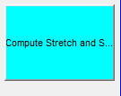

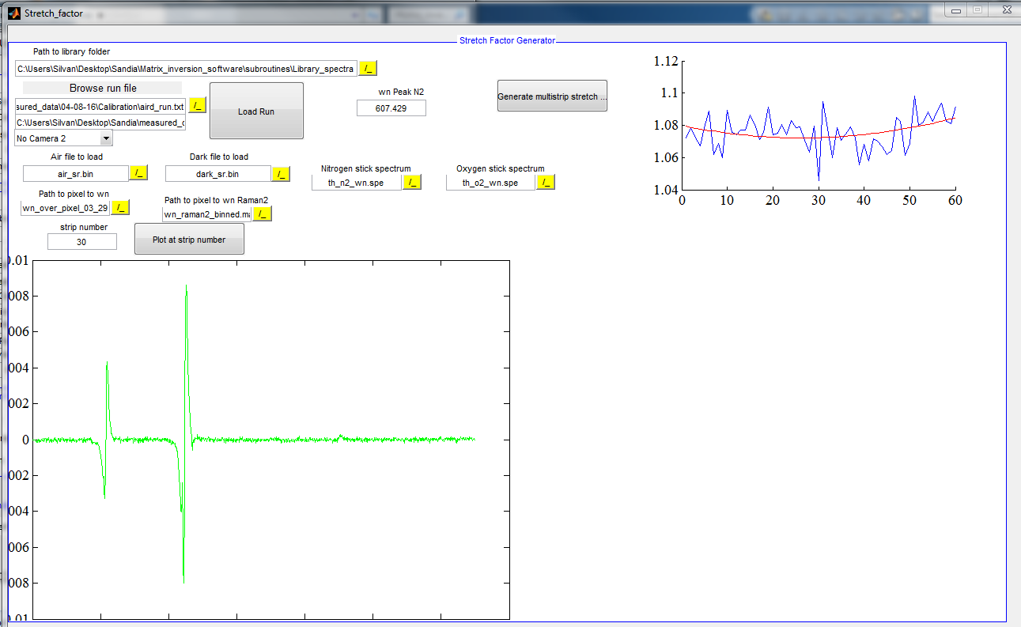

* Creates a strip dependent stretch factor, correcting for difference in transfer function and spectrally resolved n2 spectrum by matching the peak values of the n2 spectrum
* Necessity not clear; there can be also used non strip dependent stretch factor for all species.
* Here is the new version of the stretch_factor GUI  
  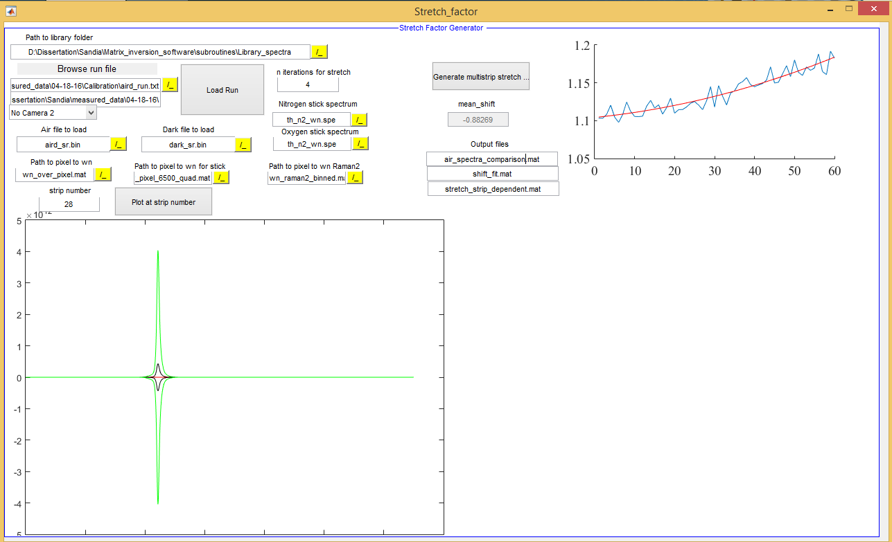
* Dark file to load: can be empty since stated in airfiles.xlsx
* Output .spe file: choose name for output transfer function
* Stretch2: stretch for polarization separation side
* Area normalization: default checked: normalize area of Ray image to 1

Hit [Generate transfer function]

Library Generation

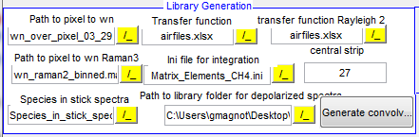

This section generates the libraries for every airfile

* Path to Pixel to wn: Pixel to wavenumber file: choose: wn_over_pixel_03_29.mat
* Transfer function: airfiles.xlsx (sheet 1, column C)
* Ini file for integration:
  + .ini file where pixel ranges for the channels are stored
    - [I/O Paths]: order of Raman channels
    - [Strips]: change for high res!
    - [Pixel shift]: how big should the libraries be
    - [plot]
    - [species]: what species X talks to compute
    - [species pix]: define binning regions
    - [LIB files] : convolved spectra; being overwritten in …/subroutines/Library_spectra/conv_spectra
    - [CALFILE]: reference data of old Sandia polynomials
  + Choose file: Matrix_Elements_CH4.ini
  + Central strip: doesn’t do anything
* Species in stick spectra: choose: Species_in_stick_spectra.xlsx; not used – keep like this

Hit [Generate convolved spectra]

Convolution of stick spectra with transfer function are performed

First normalization and air calibration

Hit [First normalization]

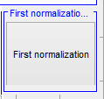

The GUI First_normalizaiton will pop up: it generates throughput normalization to flatten the profiles of the species

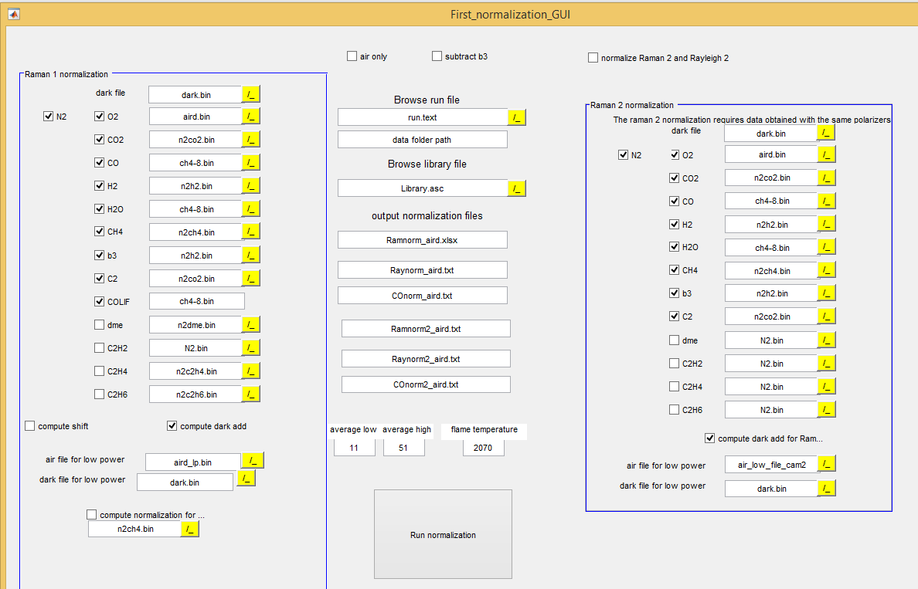

* Raman1 normalization:
  + Choose files which are used for normalization
    - Computes shift (default unchecked): determines the shift of the spectra by assuming the crosstalk factor of CO2<<O2 in air being = 1 ( if not there must be a shift in the library spectra!),  
      slows down code if checked
    - Compute dark add (default checked): does the dark correction composite of:
      * Dark drift
      * Dark add determined from aird and aird_lp image (giving a YAG energy proportional correction term (signal in CH4 channel)
* Air only: unchecked: doesn’t use other species
* Subtract b3: unchecked; if checked it subtracts the signal on the b3 channel to get 0
* Browse run file: aird_run.txt
* Browse library file: Library_airdtf1_24.asc – use just one library
* Output normalization files: state here which files are filled with found normalization
* Average low/high: state which pixel range to get YAG gain, etc – can be commented out because performed in next step
* Flame temperature: not used any more. Temp for ch4-8.bin to tweak bowing vs. throughput normalization

Hit [Run normalization]: figure comparing old and newly found normalization factors will pop up

Air calibration

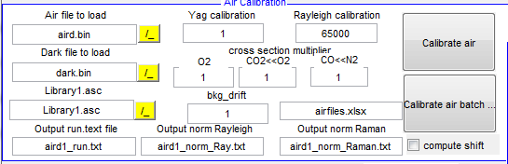

This section generates the calibration factors for N2, O2 and some x-talk factors by comparing measured files to theoretical concentrations

* Airfiles to load: only for single files
* No other entries necessary

Hit [Calibrate air batch]: fills in values found for N2, O2, Yag-Gain, x-Talks CO2<<O2, CO<<N2 in airfiles.xlsx, sheet2 and plots results: profiles should be flat and at the correct concentration

Pure Gas Calibration

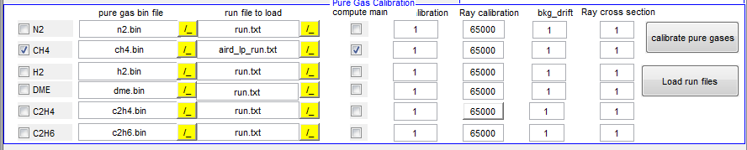

How it works:

1. Kills all species except the one you want to calibrate
2. Adjusts Raman response factor so that T_pg matches T_thermocouple
3. Adjusts X-Talk factors for this species

Perform only for ch4 and h2 (n2 is done in previous step with air) consecutively

* Load aird_run.txt . – for ch4: aird_lp_run.txt
* check compute main: create new response factor (actual calibration), if unchecked it takes the original value of response talk factor in run_file.txt (necessary if e.g. thermocouple was not in place)

Hit [calibrate pure gases]

Flat flame burner calibration

For flat flame (ch4-):

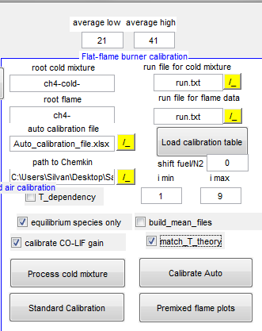

For Hencken:

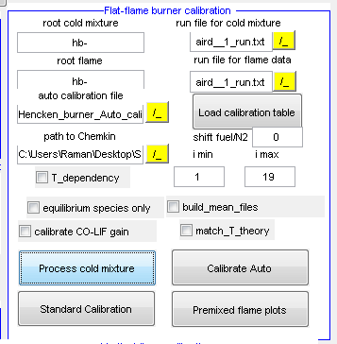

How it works:

|  |  |  |  |  |  |  |  |
| --- | --- | --- | --- | --- | --- | --- | --- |
| Main | Crosstalk 1 | Crosstalk 2 | TolFun | TolX | MaxIter | Istart | iend |
| CO2 | CO2 | CO2 | 1,00E-06 | 1,00E-02 | 31 | 1 | 5 |
| species talked onto | Species talking onto | Don’t use, special feature | Parameter for optimization | Parameter for optimization | # of max iterations | Ch4-X flame to start with | Ch4-X flame to end |

1. reads Auto_calibration_file.xlsx, sheet 1  
   e.g.:
2. executes step by step the response talks / crosstalks to be modified-> for these steps create a new Auto_calibration_file.xlsx, make entries in rows and load it
3. based on the ch4-x to ch4-y files stated matlab does a minimum difference optimization
4. plots results with old and new response talk factors (x talk factors respectively)

* average low / average high: states pixel ranges to use for function
* root cold mixture: ch4-cold- (for hencken: hb- since there are no cold files)
* root flame ch4- (for hencken: hb-)
* path to Chemkin: state path where ff calculations are stored: methane_flame_theory.xlsx
  + for hencken: Hencken_theory.xlsx
* T_dependency: work in progress- don’t use it (uncheck)
  + i min / i max: range of ch4-x flames to take
* run_file for cold mixture: aird_run.txt
* run_file for flame: aird_run.txt (only different one if you don’t want to use the same one -what is rarely done)
* [Load calibration table]: hit this in case not running with original runfile – hardly ever used
* Shift fuel / N2: used for Hencken flame where phi is not determinedd from cold gases – in case MFC where miscalibrated – to pick right phi
* Equilibrium species: default checked: kills equilibrium species (e.g. CH4, O2 in rich flames)
* Build mean files: default checked (when running the first time): process mean of 100 files ( need to be build only once; saved as ch4_mean, where 9 images are in one set, each shot stands for mean of one ch4-x)
  + Uncheck later for tweaking parameters – speeding up
* Calibrate CO-LIF gain: (arguable) LIF gain is fixed/updated to theoretical value that CO-LIF fits theoretical value
* Match_T_theoretical: default checked: fixes temperature to equilibrium calculations

Hit [Process cold mixture]: process cold then flame results -> get ch4/N2 ratio in cold

Hit [Standard Calibration]: does the optimization of the parameters stated in Auto_calibration_file.xlsx

* Check the resulting plots: species that fit the calculations can be stopped in optimization
* Since multiple dependencies are ther it makes sence to do e.g. CO2, O2<<CO2, CO2, O2<<CO2 sequentially in one Auto_calibration_file.xlsx
* Use this function carefully; check if found paramters are not to far off of 1; if so there must be some other issue (e.g. shift, bowing, normalization,… wrong) –

[Calibrate Auto]: not recommended to use ( for T_dependecy plots); to use: check the species to tweak on the right side:

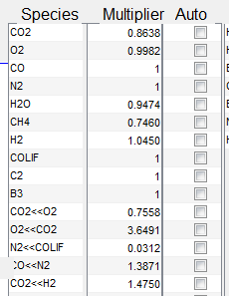

* Takes i_min / i_max flames to perform calibration

[Premixed flame plots]: not used; processes all 100 shots and plots radial profiles

Vertical flame calibration

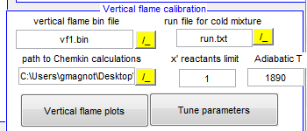

Work in progress; don’t use

* Used to determine shift of cameras against each other
  + Minimize crosscorrelation of T_pg and T_ray
  + Output is printed in Raman_GUI: - Camera Parameters -, center shift
    - For CO camera done manually
    - So far do it manually (T_pg and T_ray) and enter it in Raman_GUI: - Camera Parameters -, center shift

Run batch mode

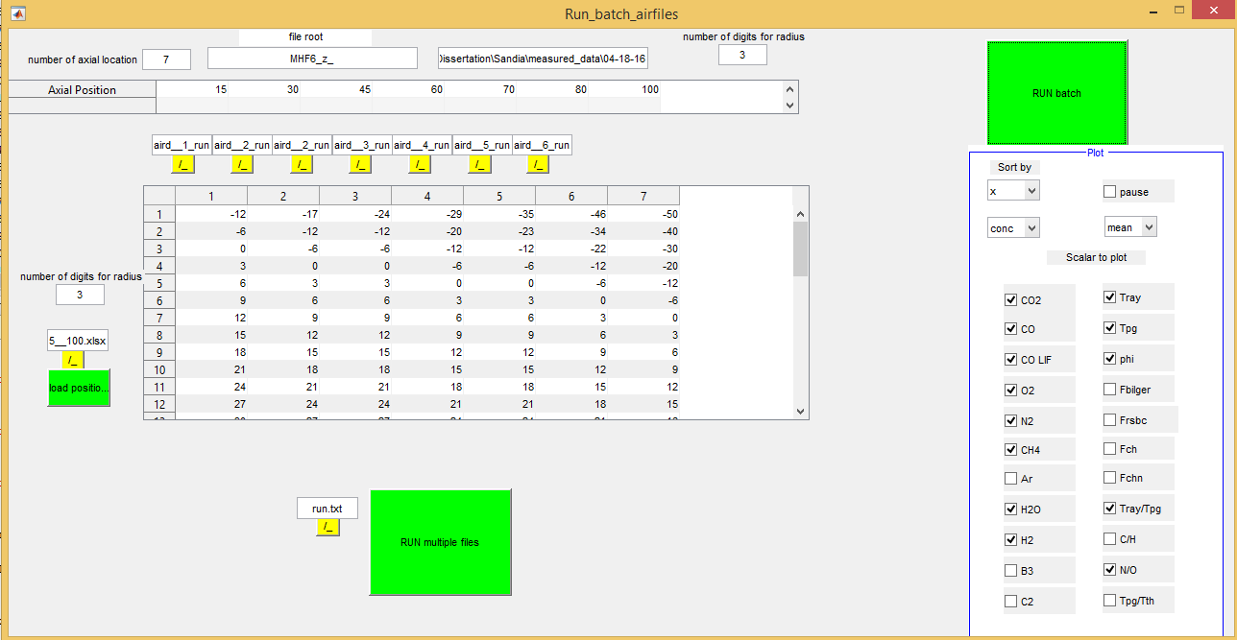

* Axial positons: hard coded in Run_Batch_airfiles
* Select runfiles for every axial position
* Load radial position .xlsx #

Hit [RUN batch]